BRANCHES IN GIT & HOW IT WORKS:

-Git doesn’t store data as a series of changesets or differences, but instead as a series of snapshots.
-When we make a commit, Git stores a commit object that contains a pointer to the snapshot of the content we staged
- zero parents for the initial commit, one parent for a normal commit, and multiple parents for a commit that results from a merge of two or more branches.
When we execute the git commit command what happen inside is:
Git checksums each subdirectory and stores them as a tree object in the Git repository.
Git then creates a commit object that has the metadata and a pointer to the root project tree so it can re-create that snapshot when needed.
Git repository now contains five objects: blobs, one tree that lists the contents of the directory and specifies which file names are stored as which blobs, and one commit with the pointer to that root tree and all the commit metadata.
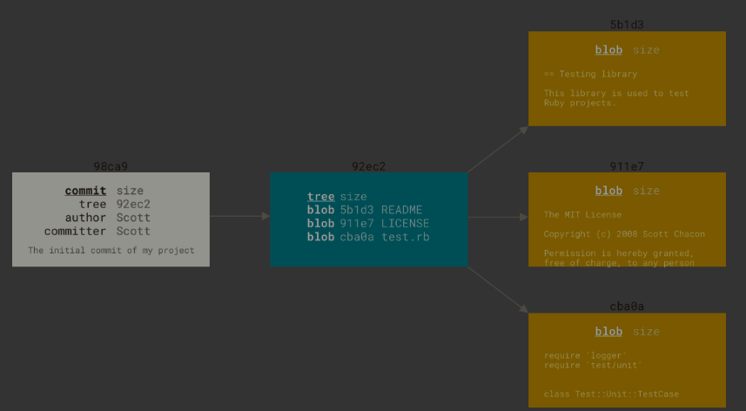
If we make some changes and commit again, the next commit stores a pointer to the commit that came immediately before it.
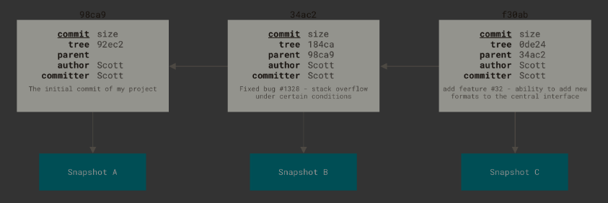
A branch in Git is simply a lightweight movable pointer to one of these commits. The default branch name in Git is master. Every time we commit, the master branch pointer moves forward automatically.
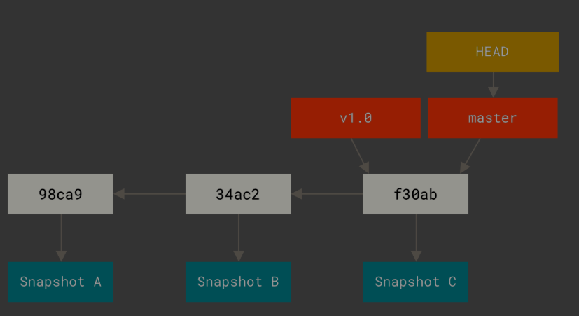
Creating a New Branch
When we create the new branch it creates a pointer to the commit we are working on currently. 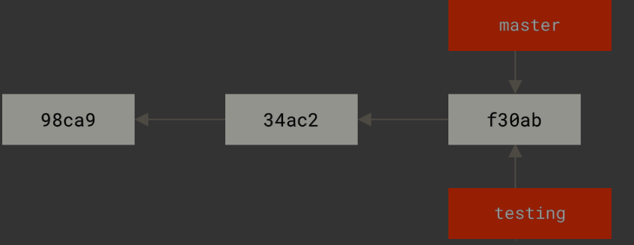
We can use the HEAD to travel between the branches
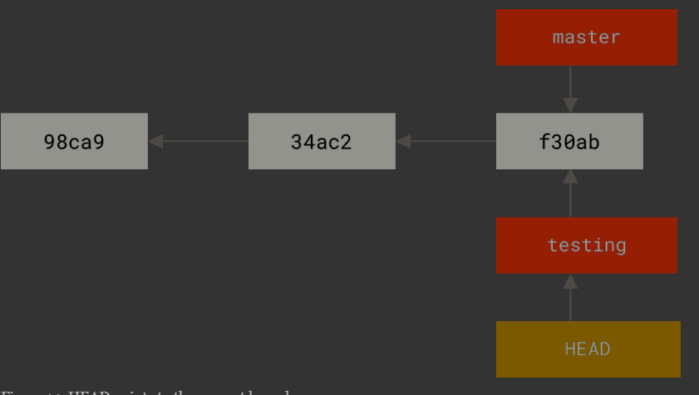
By default it points to the master at first.
The head moves forward when a commit is made.
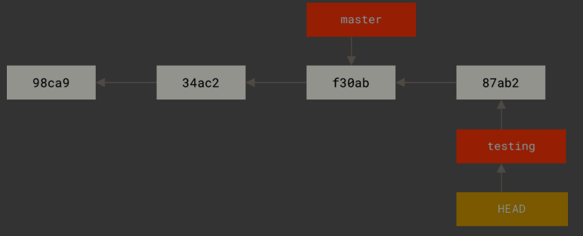

GIT BRANCHING STRATEGIES
1)GITFLOW
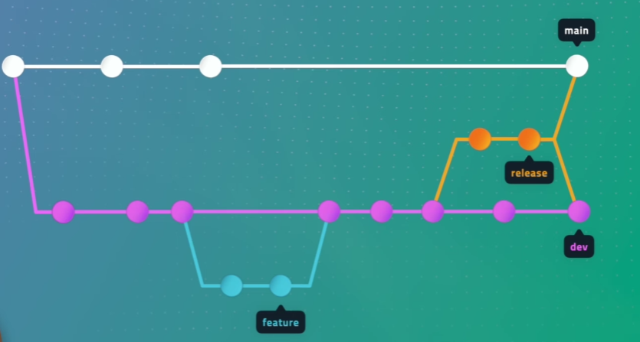
It is widely used in teams that follow structured release cycles, CI/CD, or enterprise software development.
It provides a very clean separation between:
- Production-ready code
- Ongoing development
- Feature development
- Release preparation
- Hotfixes
THE FIVE MAIN BRANCHES IN GITFLOW
1)Project SETUP
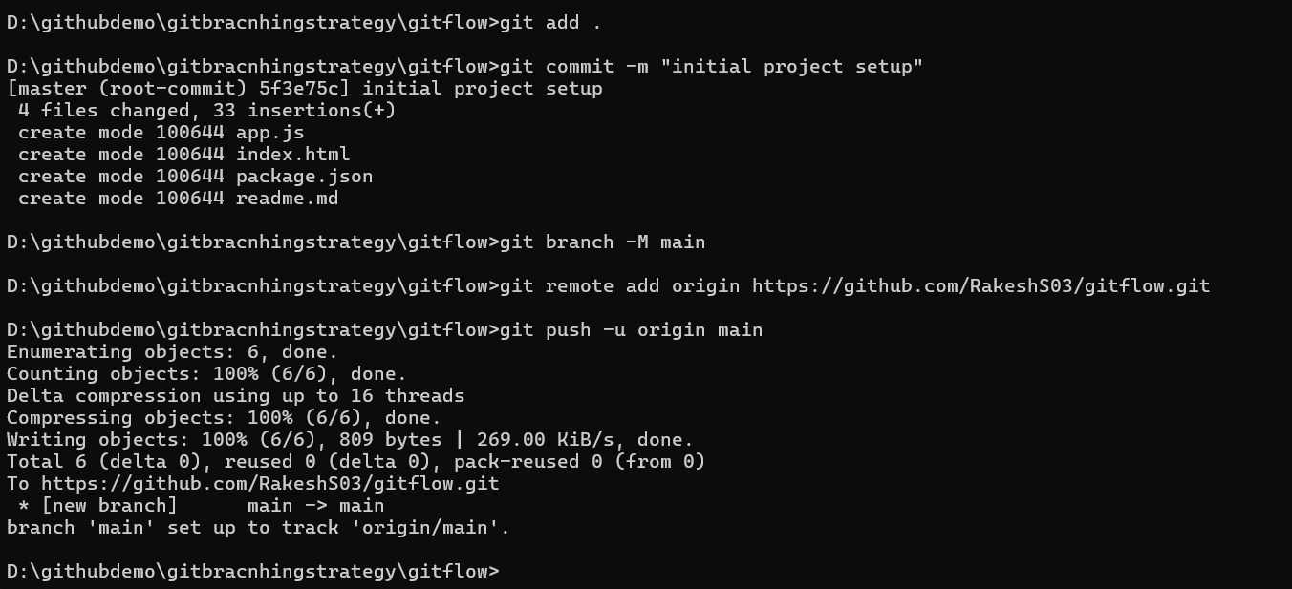
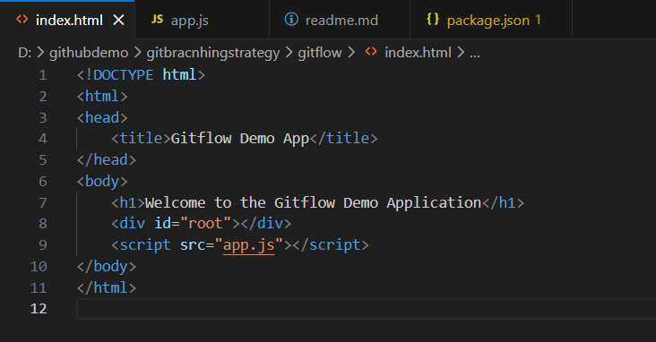
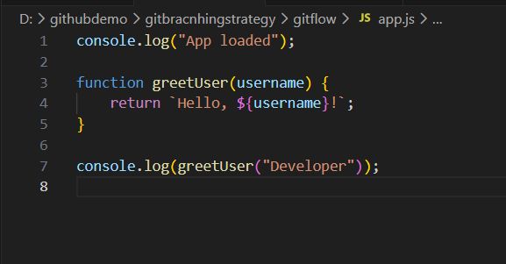
Initialized the repo with the initial project files
2)Create the develop branch

Commands used: git checkout -b develop main- to create the develop branch from main branch and switch to it
git push -u origin develop – to upstream the develop branch into the remote repo.
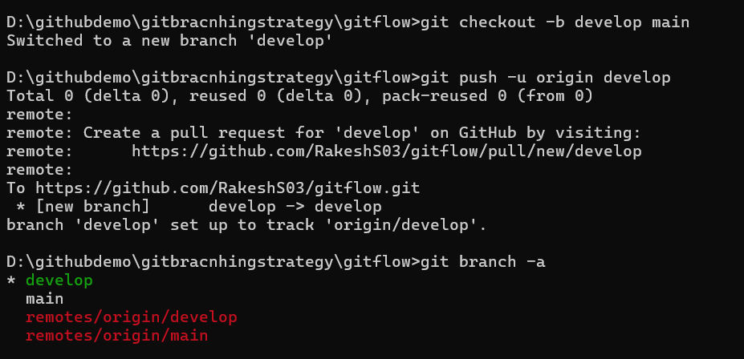
3) Create Feature Branch (Add login UI)
Branch off from develop
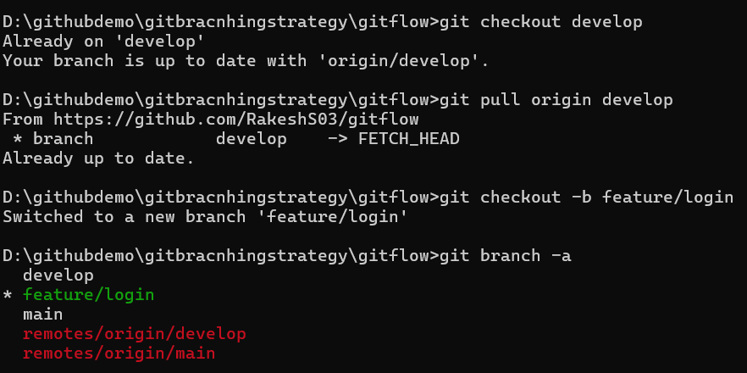
4)Now introduce the changes to the files (adding login)
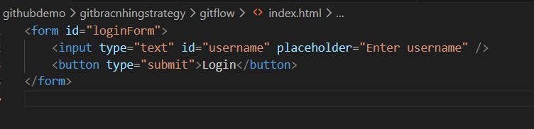
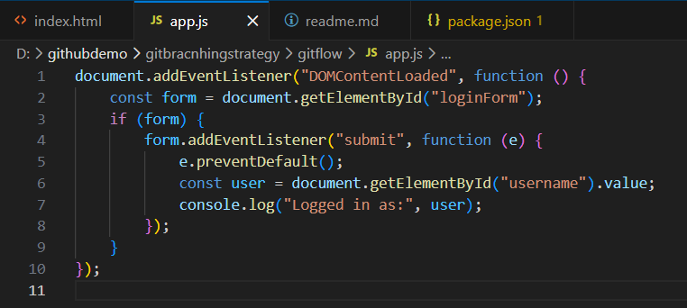
Commit and push the changes to the remote feature branch
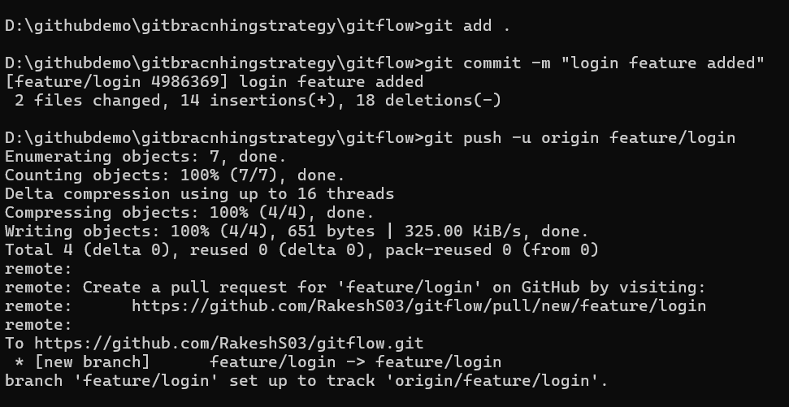
Merge the feature with the develop branch
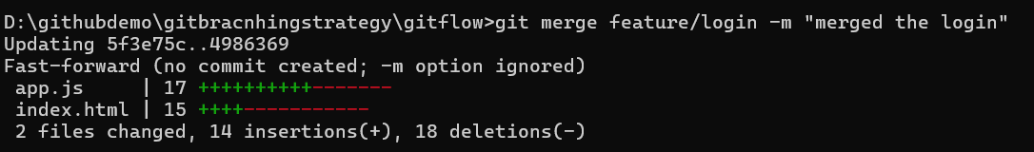
Now create the release branch for releasing the feature
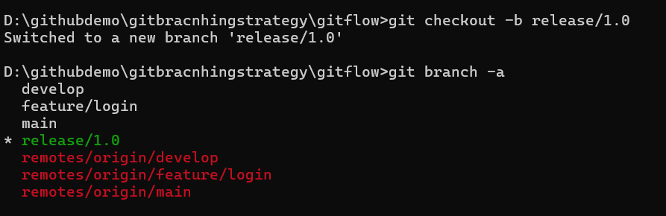
Finish the release by merging to the main branch
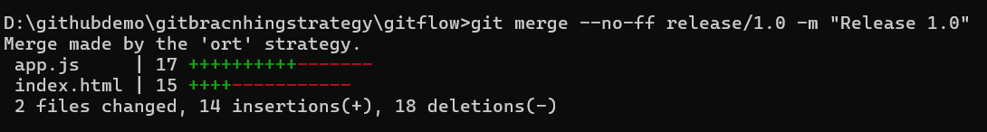
ORT-optimized recursive tree
Hotfix (Bug in production main)
Bug: login form crashes when username is empty.
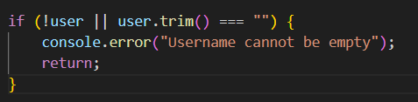
Added the new condition
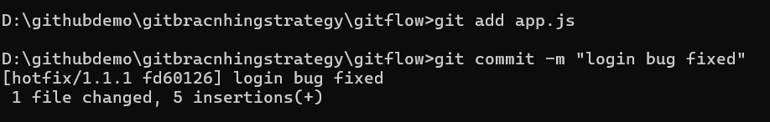
Merge into main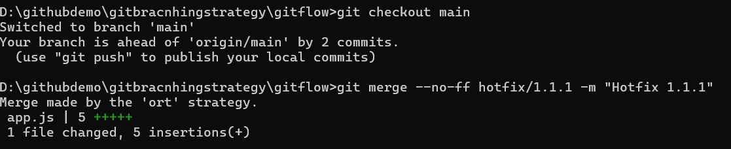
Merge back into develop
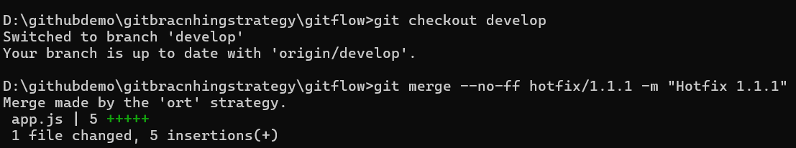
WHEN TO USE GITFLOW?
✔ Large teams
✔ Release cycle is predictable (monthly/quarterly)
✔ Enterprise projects needing strict control

GITHUB FLOW
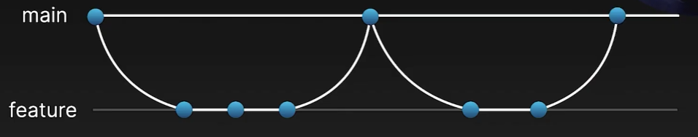

Steps in GitHub Flow
1. Create a Branch
Whenever we start a new feature, bug fix, we create a new branch from main.
2.Commit and Push Changes
As we write code, commit regularly
3.Open a Pull Request (PR)
A pull request allows us to:
- Show our changes to our team
A PR is usually opened when the feature is complete.
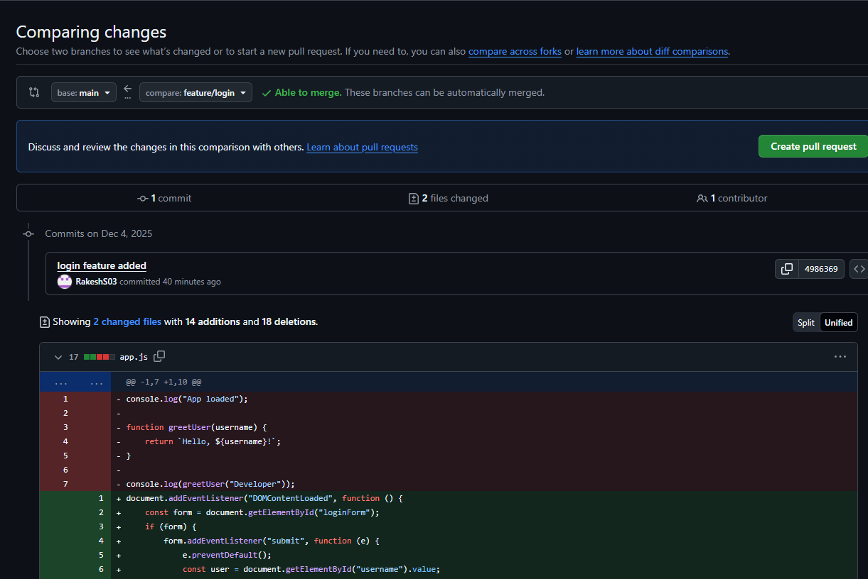
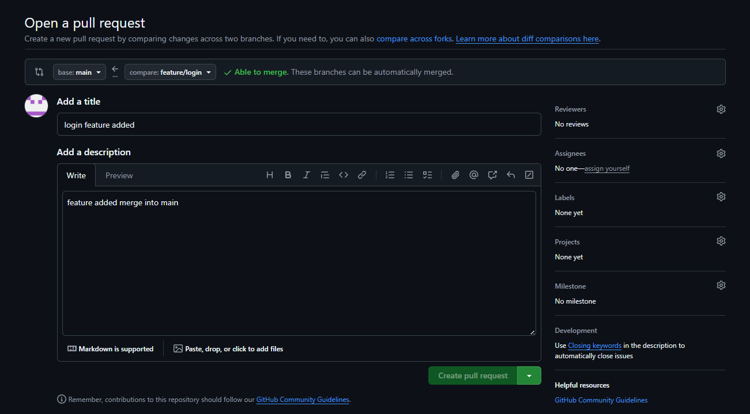
4.Resolve Conflicts (if any)
If two branches modify the same lines, conflicts occur.
5.Merge to Main
Once everything is reviewed and approved, merge the branch into main
TRUNK BASED DEVELOPMENT
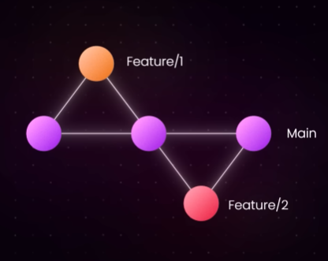

Trunk-Based Development is a branching model where all developers work on a single main branch.
Instead of long-lived branches, developers create very small, short-lived branches or commit directly to the trunk.
This approach encourages fast integration, continuous testing, and continuous delivery.

Core Principles :
1. One Main Branch (Trunk)
2. Short-Lived Feature Branches where developers may create a feature branch
3. Frequent Commits
4. Continuous Integration (CI)
5. Feature Toggles / Flags

Here it works same as the Gitflow but the branches are merged quickly and deleted
GITLAB FLOW
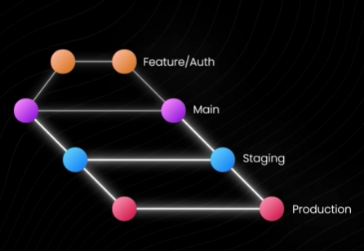

Environment Branching
Use separate branches for different deployment stages:
main → pre-prod → production
How it works:
- Developers merge to main
- When ready to test merge main → dev/test
- When ready to release → production
Used in:
- Large teams
Release Branching
Here, we create branches per release:
main
release/v1.0
release/v2.0
Example:
Bug in version 1.0? → Fix in release/v1.0
New features → Go to main.
Production Branching
Used when deployments are frequent
main → production
Flow:
- Develop on feature branches
- Merge into main
Best for:
- Web apps
- Continuously deployed apps
IMPLEMENTATION:
Initialize Repo
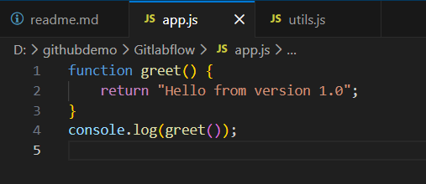
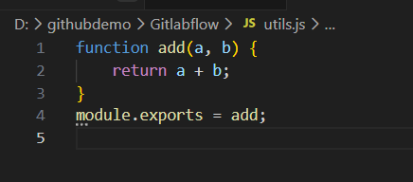
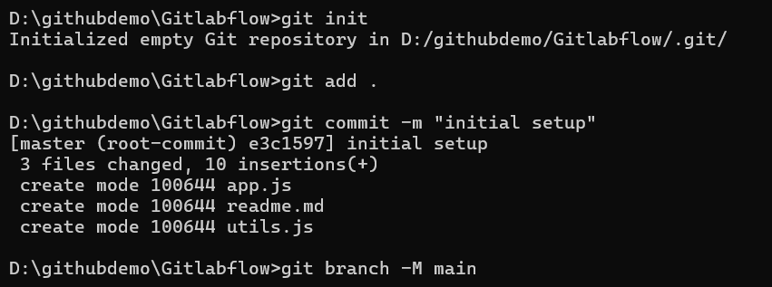
Create Environment Branches
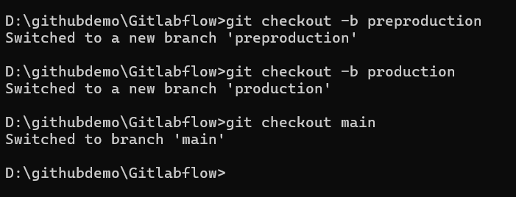
Create a Feature Branch
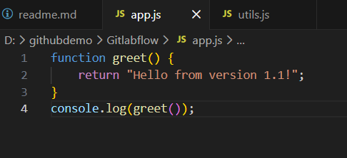
Made changes in app.js file
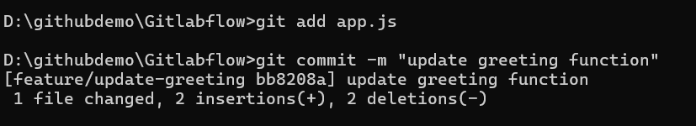
Merge Feature → main (via merge request)
--no-ff used because No Fast-Forward Merge
Because it becomes impossible to see where a feature began and ended.
Delete the branch after merging
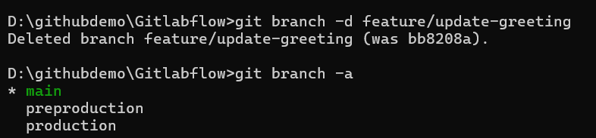
Promote code from main → pre-prod
Staging environments must receive changes only after validation.
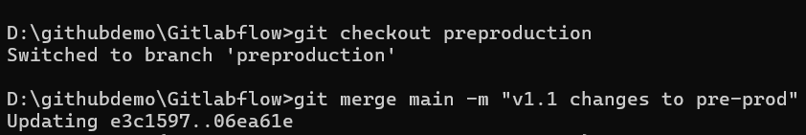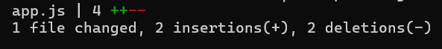
Test in pre-prod
QA team testing occurs here.If approved → promote to production.
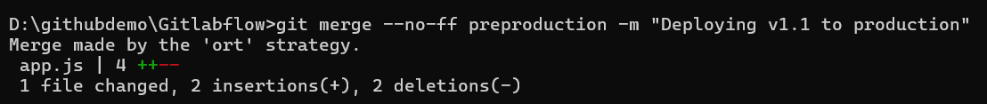

MERGE CONFLICTS SCENARIOS AND HOW TO RESOLVE THEM
TEXTUAL CONFLICT (Same file, overlapping edits)
Example: Two developers edited the same lines in app.js.
When does it happen?
- Git merges two branches where the same lines of a file are changed.
- Git cannot decide whose version is correct.
How to resolve
- Open the conflicted file:
- code app.js
- Manually edit the marked section:
  - Keep our part, their part, or
  - Combine them meaningfully.
- Stage the resolved file:
- git add app.js
- Complete the merge/rebase
- git commit
- git rebase --continue
Best practice
- Make smaller, more frequent commits.
- Sync/rebase from main often.

2. DELETE / MODIFY CONFLICT
Example:
- Developer A deletes config.py.
- Developer B modifies config.py.
Merging these causes conflict.
When does it happen?
One branch deleted a file that another branch modified.
How Git shows it
both deleted and modified: config.py
How to resolve
we choose one:
Option A — Keep the file (discard the deletion)
Option B — Accept the deletion
Complete merge
Best practice
Avoid deleting shared config files without a team conversation.

3. RENAME CONFLICT
Example:
- Branch A: login.js renamed → auth.js
- Branch B: login.js renamed → signin.js
OR
- One branch renames a file, another modifies it.
When does it happen?
Git detects different rename paths or rename-vs-edit issues.
How Git shows it
CONFLICT (rename/rename): login.js renamed in both branches
How to resolve
Step 1 — Choose final filename
Step 2 — Manually merge contents:
Step 3 — Stage the chosen file:
Step 4 — Remove the losing file if needed:
Step 5 — Commit:
git commit
Best practice
Use clear naming conventions; rename early in a sprint before many edits.

4. BINARY FILE CONFLICT (Images, PDFs, videos, .zip, etc.)
When does it happen?
Two branches modify a binary file (e.g., .png, .exe, .mp4).
Binary files cannot be auto-merged.
How to resolve
Choose one version:
Option A — Keep our version
Option B — Keep their version
Option C — Provide a new replacement file
Best practice
- Store large binary artifacts in Git LFS.
- Avoid committing frequent binary changes.

Recovering deleted code
Git keeps history and reference logs, even we delete a branch, objects usually remain until garbage collection.
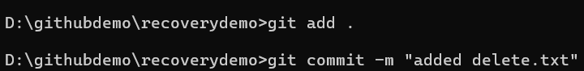
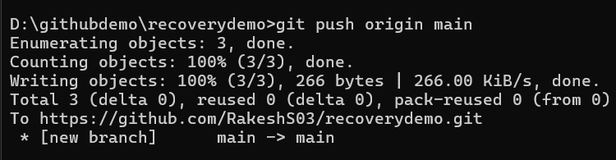
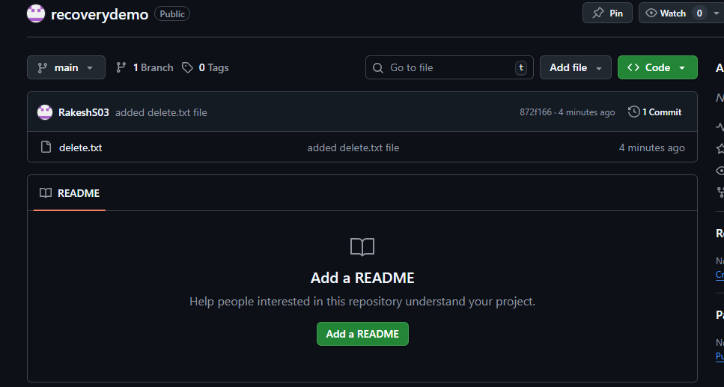
Modify file & push again
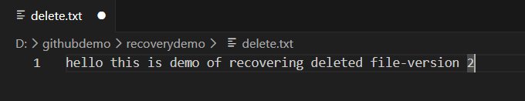
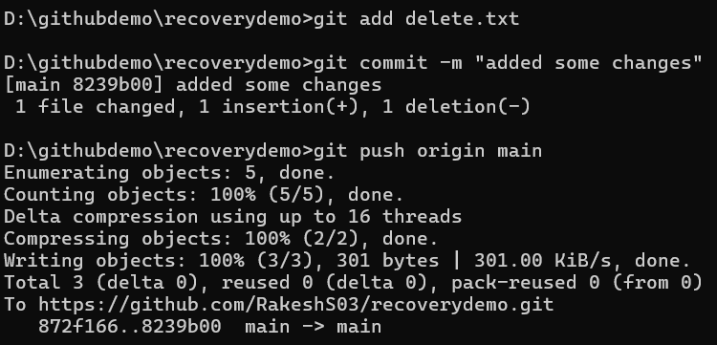
Delete file locally
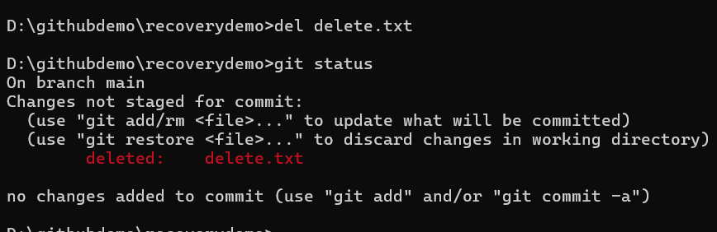
Recover (file NOT committed yet)
Delete file AND commit the deletion
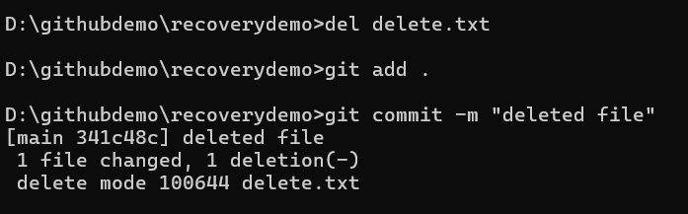
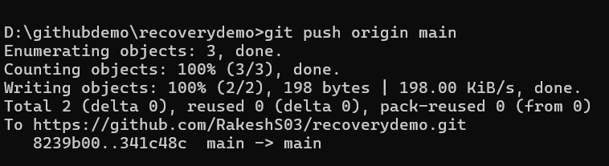
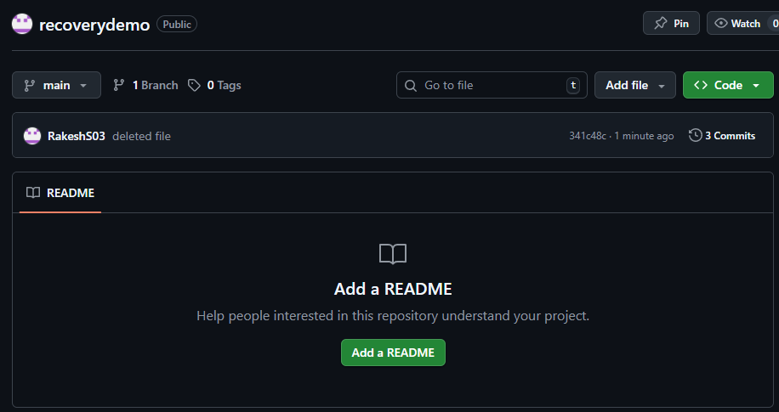
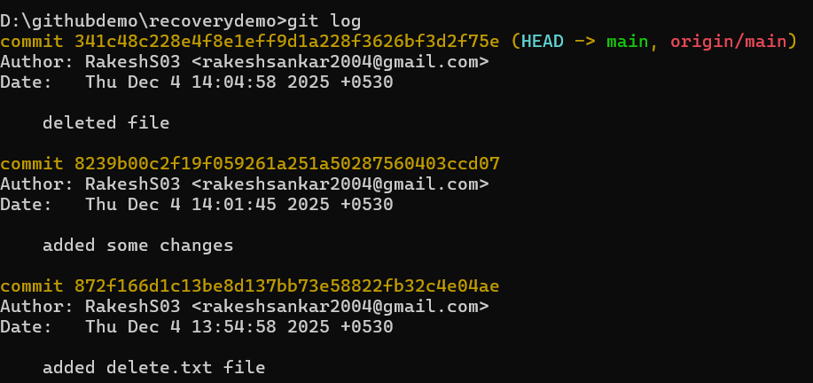
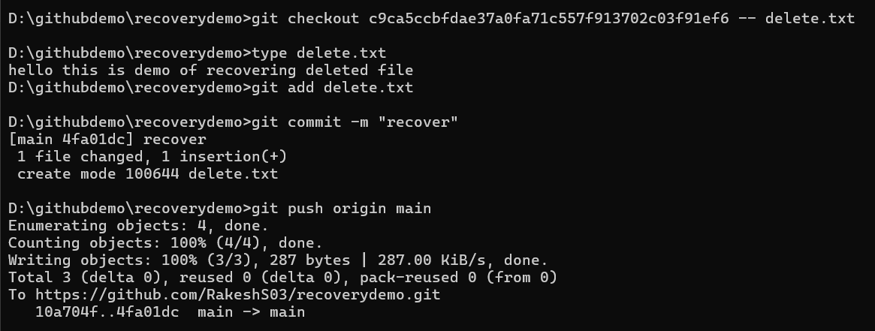

git log vs git reflog — differences and use cases
- git log: shows commit history reachable from a ref (branch tip) — the visible commit graph. Use to inspect commits, diffs, authors, messages.
- 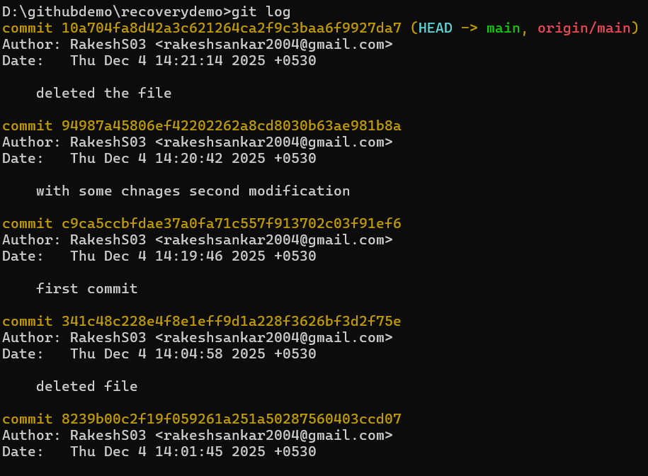
- git reflog: records movements of refs (HEAD, branch tips) in our local repo — includes commits that may not be reachable from git log (e.g., after a reset). Reflog is local only and is the go-to for recovery of lost commits/branches.
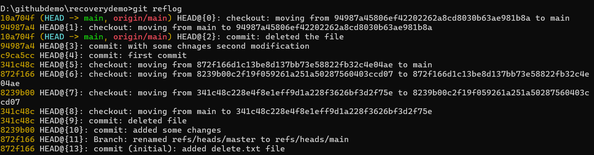
Use reflog when we have moved HEAD, performed resets, rebases, or deleted refs and need to find previous tips. Use log for normal history inspection.

